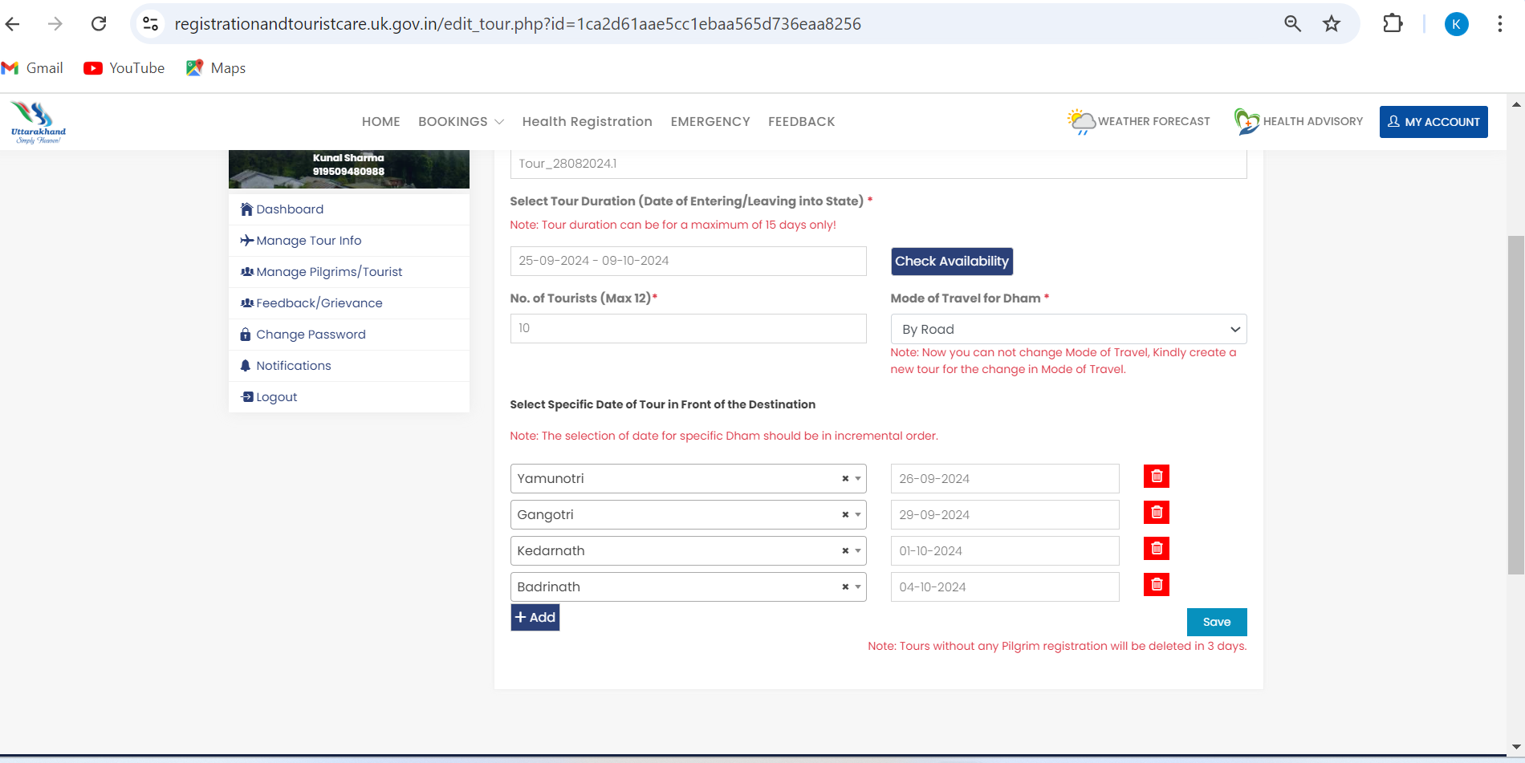
Personal Care
and beauty go live screenshots :
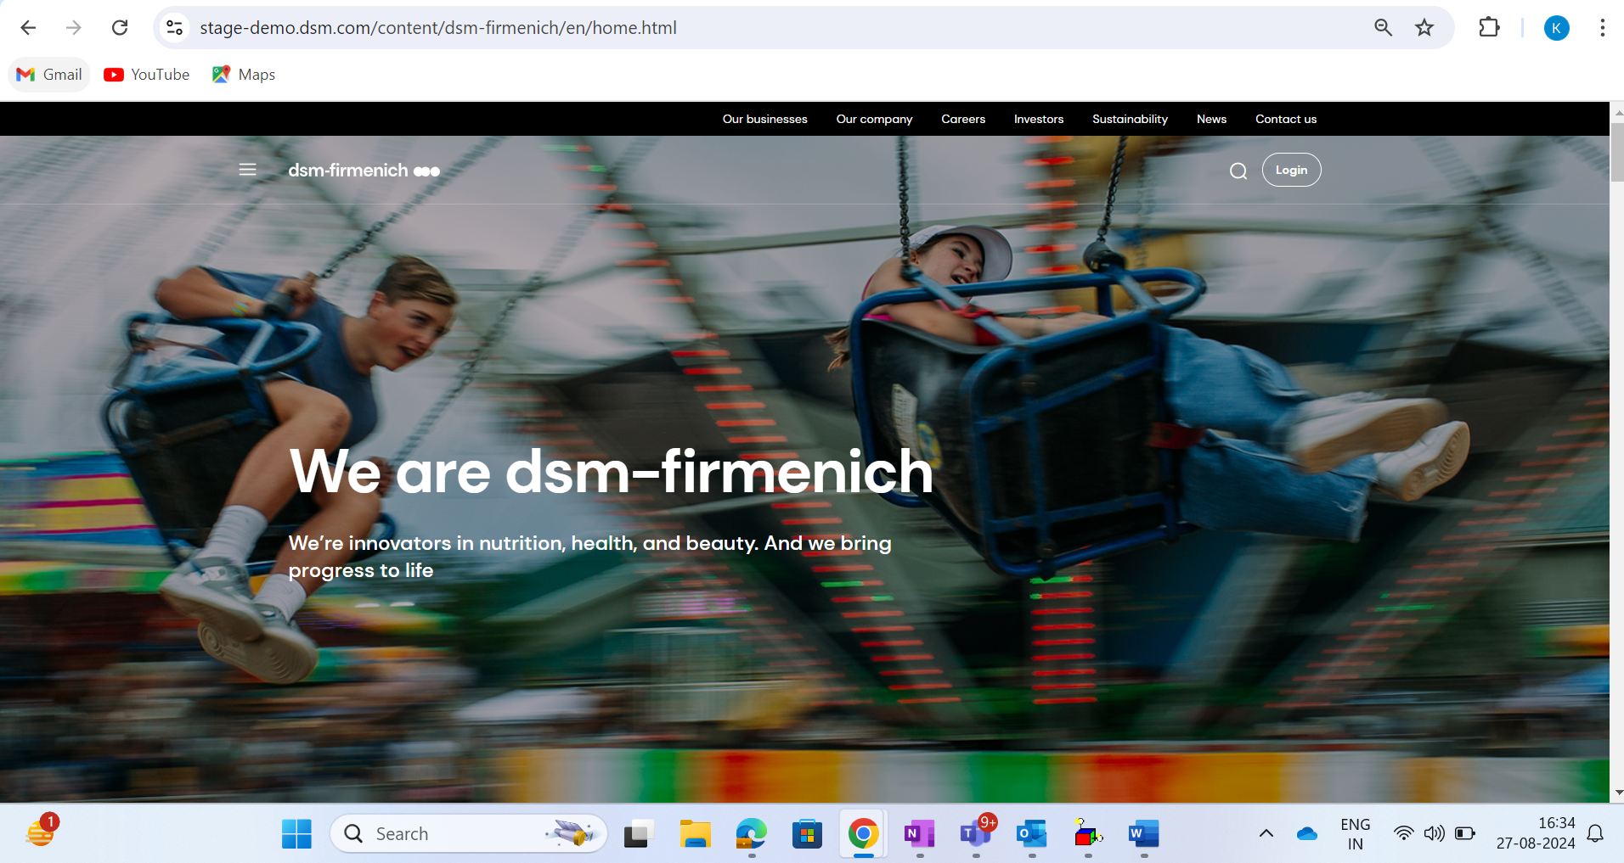
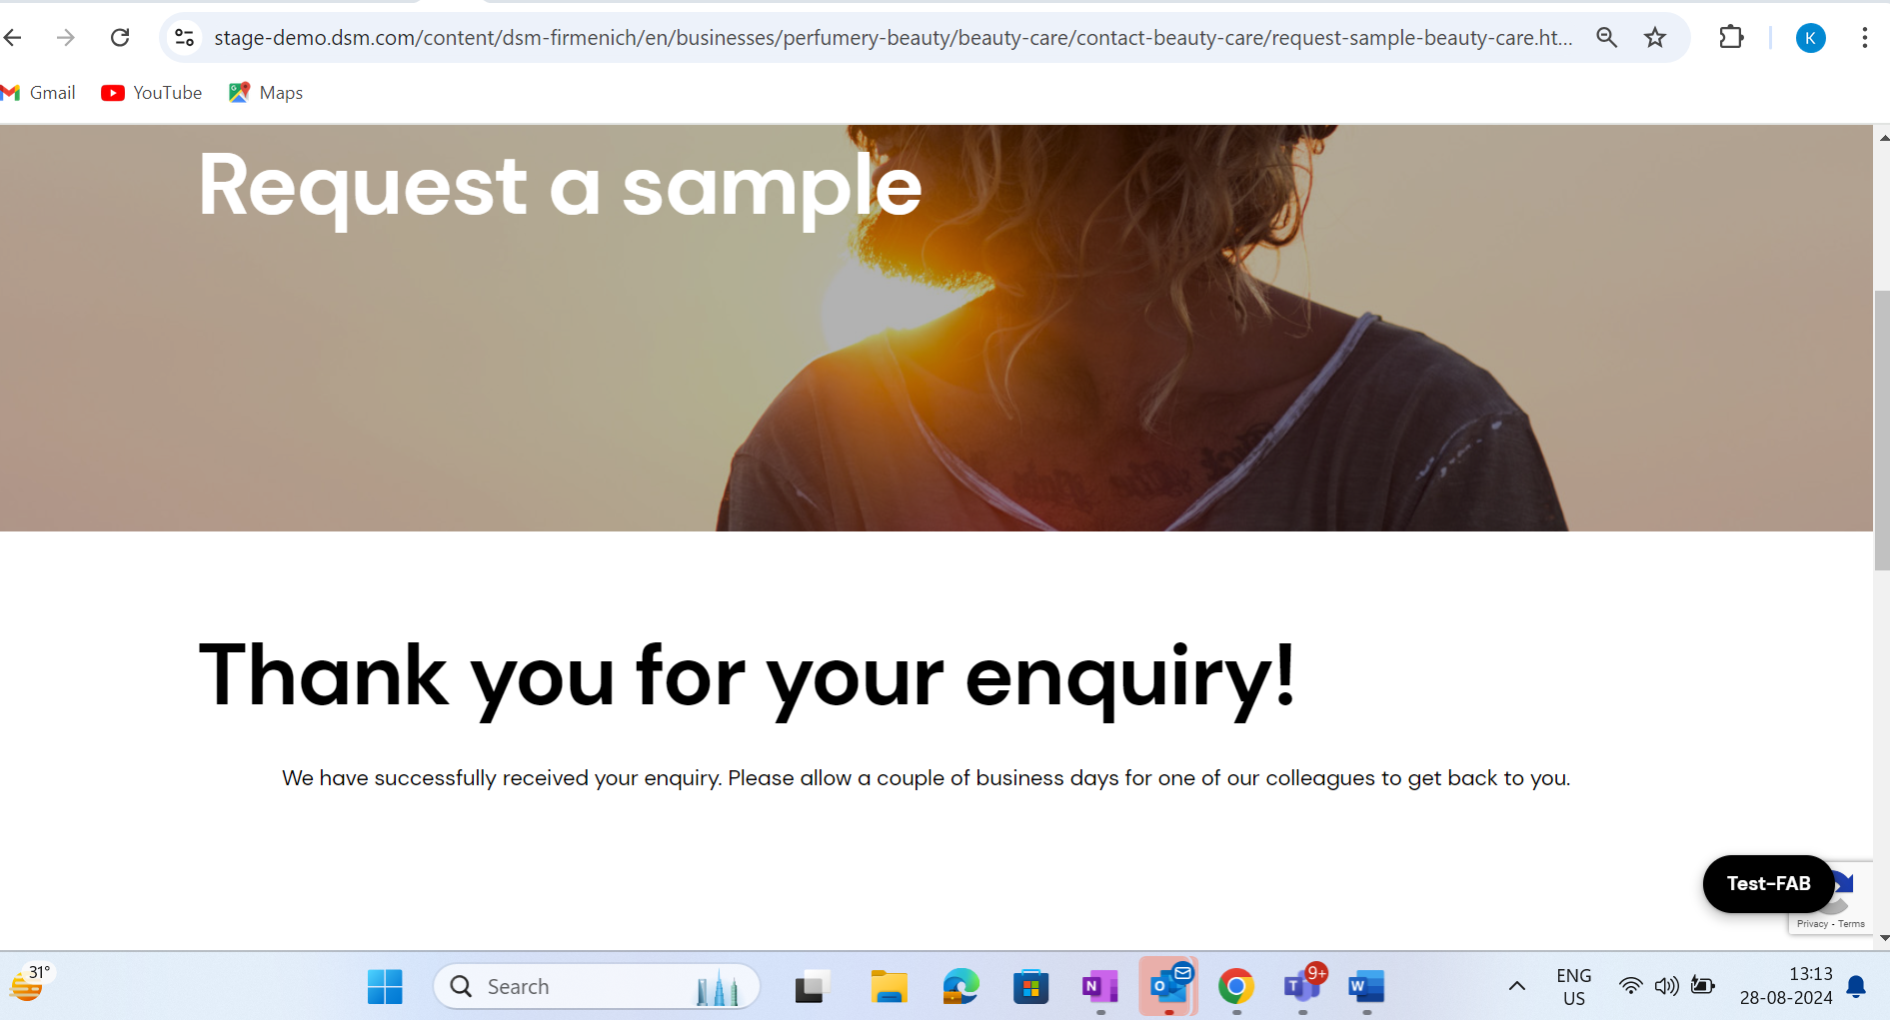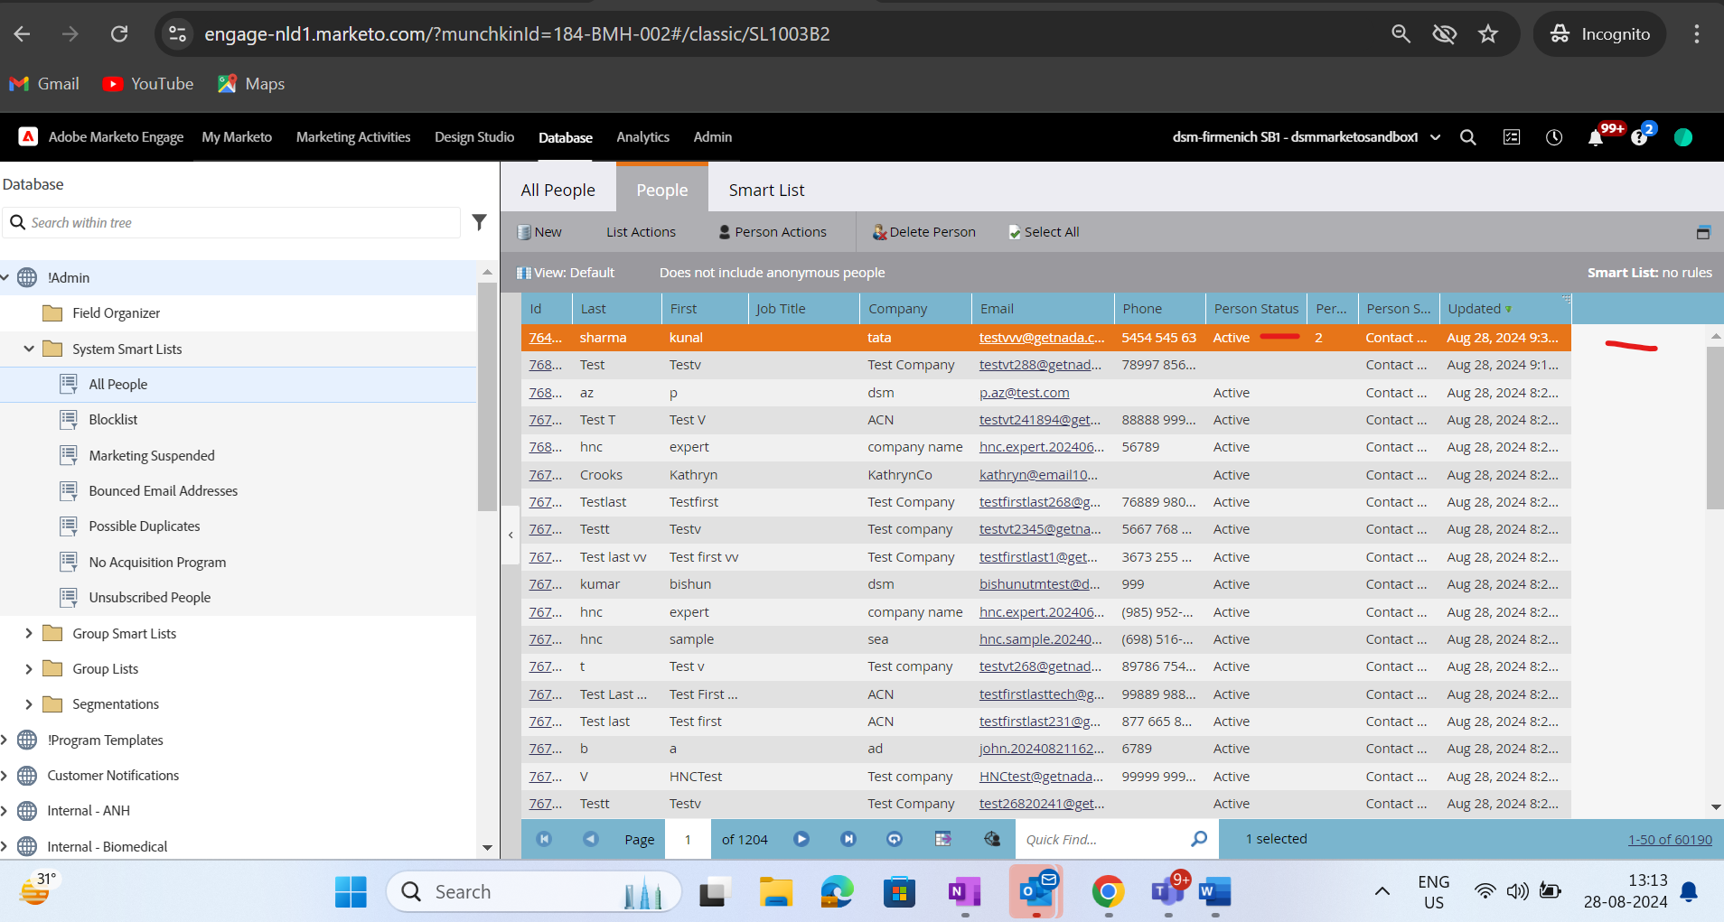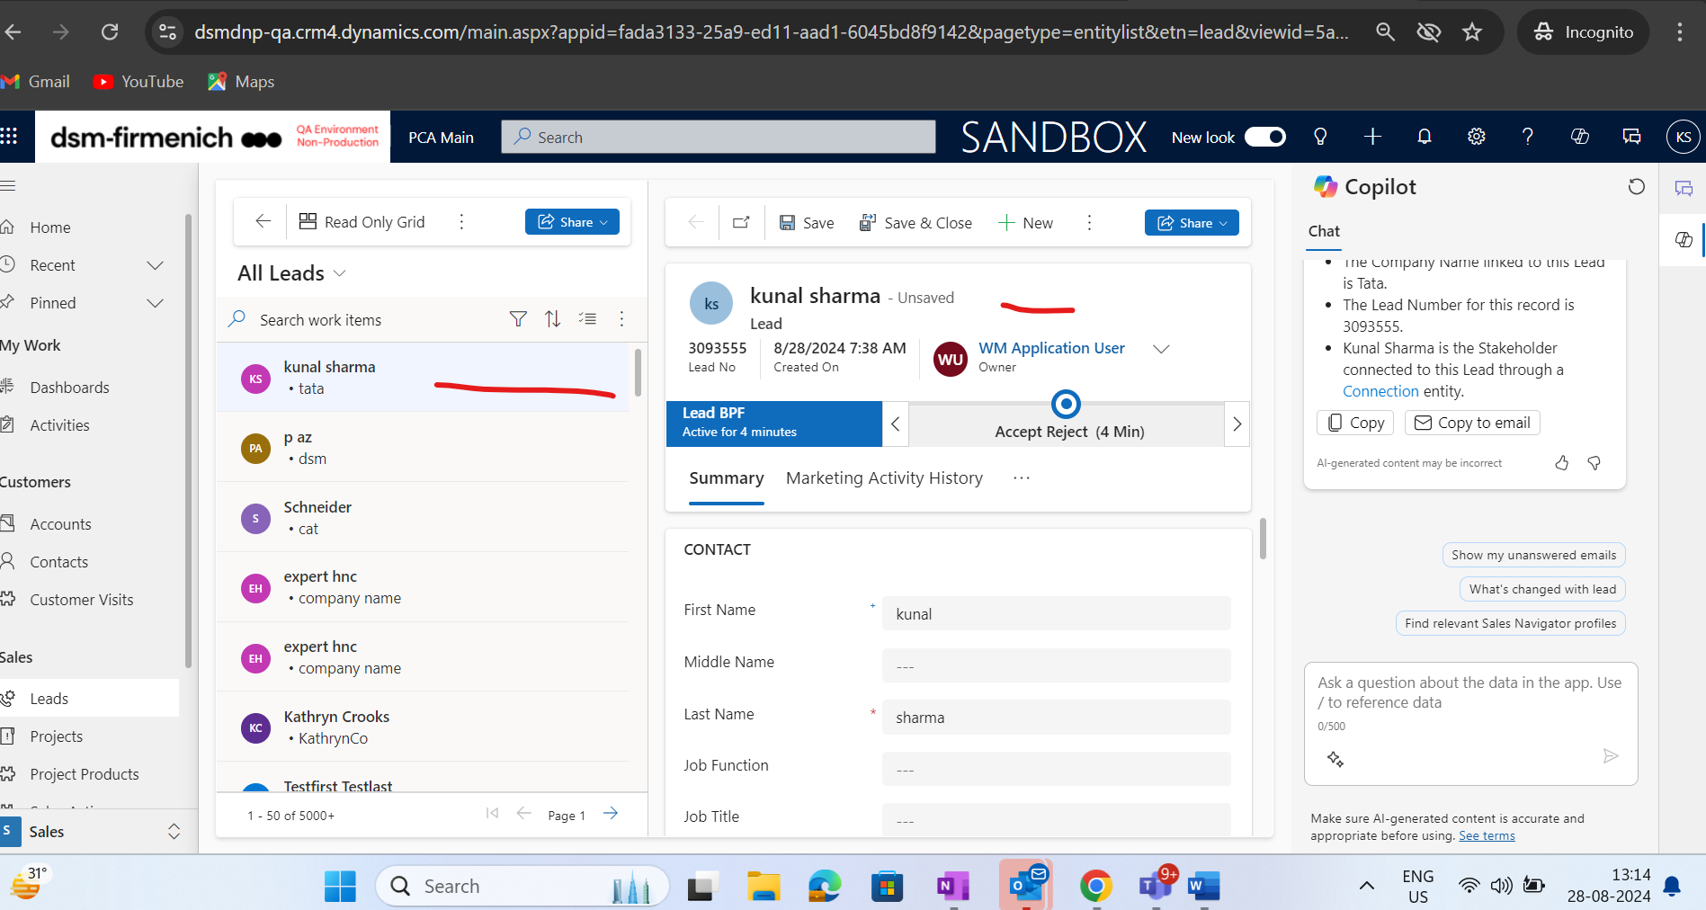
- Youtube link is not configured correctly on footer
- Some of the time it is observed that on opening the personal care site for the first time in browser it is redirected to dsm prod.
- Alignment of cards is not proper on this page :
https://stage-demo.dsm.com/content/dsm-firmenich/en/businesses/perfumery-beauty/beauty-care/formulation-inspiration.html
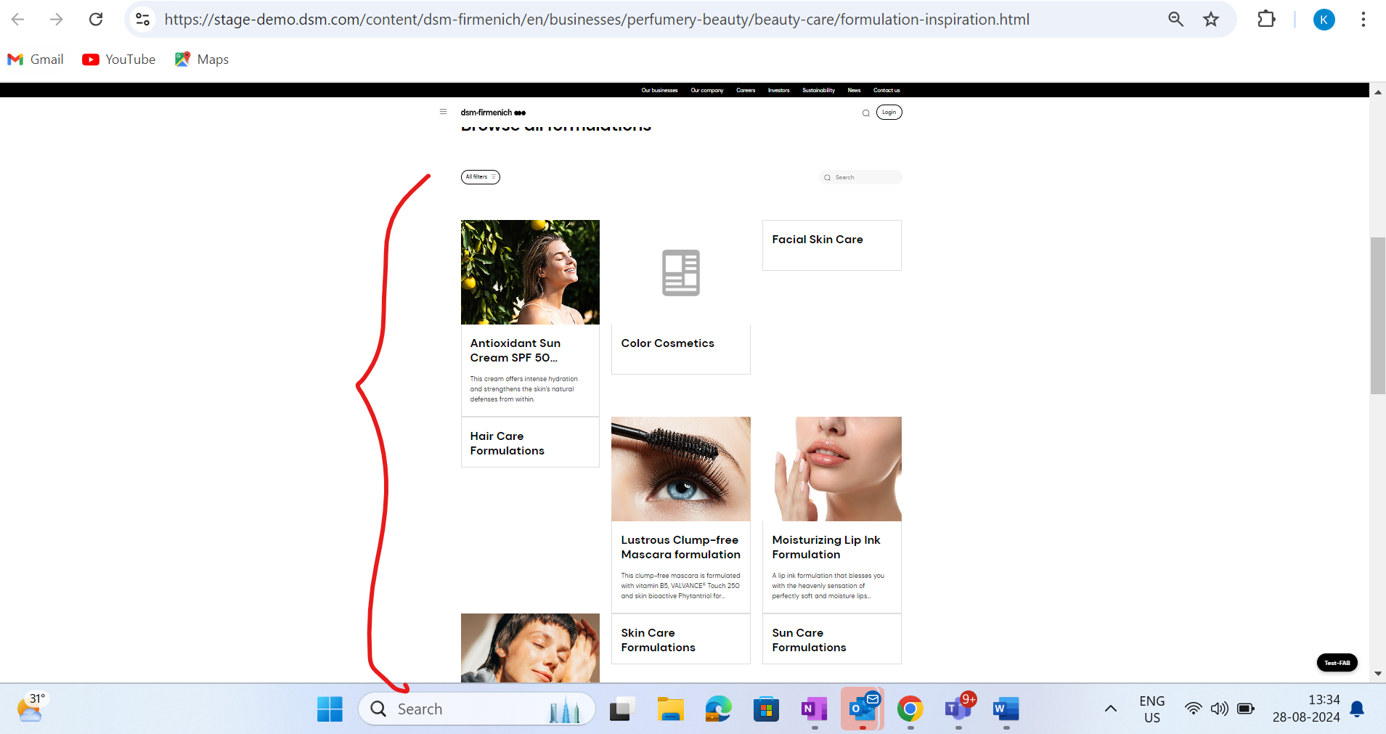
- Duns and bredsheet not working on forms
- Nothing is authored on this page : https://stage-demo.dsm.com/content/dsm-firmenich/en/businesses/perfumery-beauty/beauty-care/trends-and-insights/tailored-beauty-trends.html

- Images are seen as broken https://stage-demo.dsm.com/content/dsm-firmenich/en/businesses.html
https://stage-demo.dsm.com/content/dsm-firmenich/en/home.html

https://stage-demo.dsm.com/content/dsm-firmenich/en/our-company.html#our_purpose

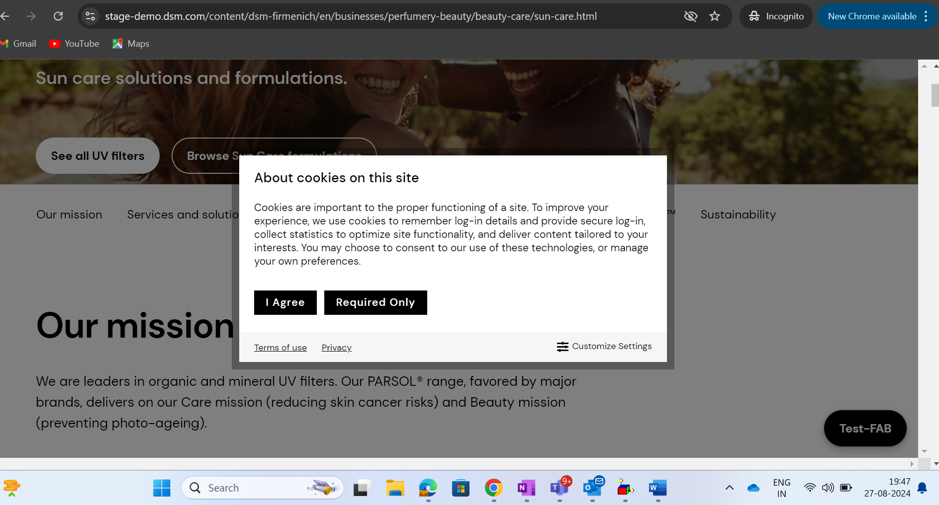

Investors Screenshots :
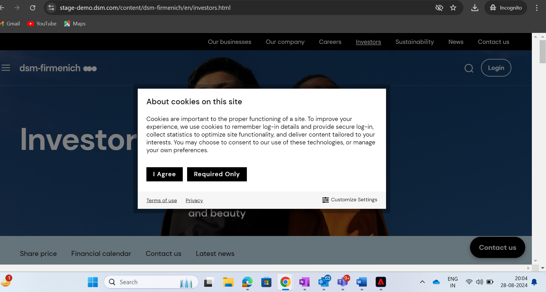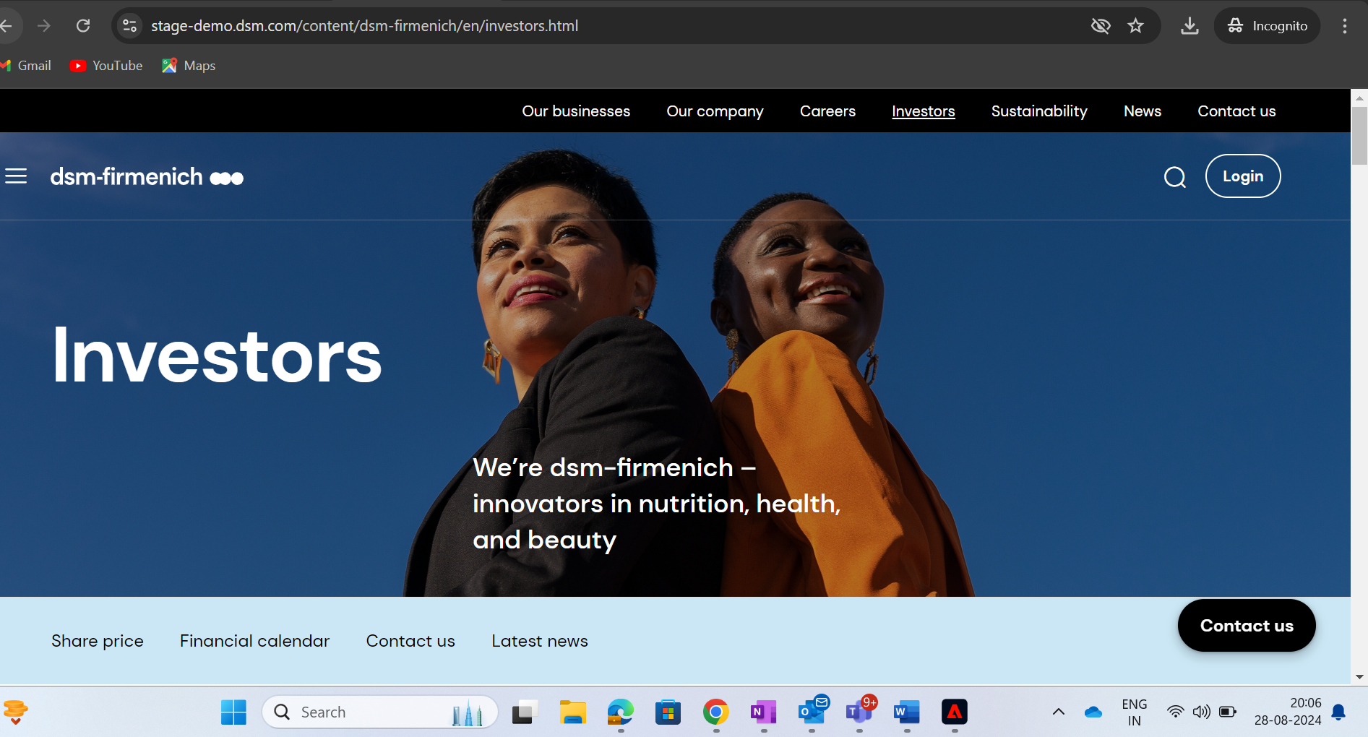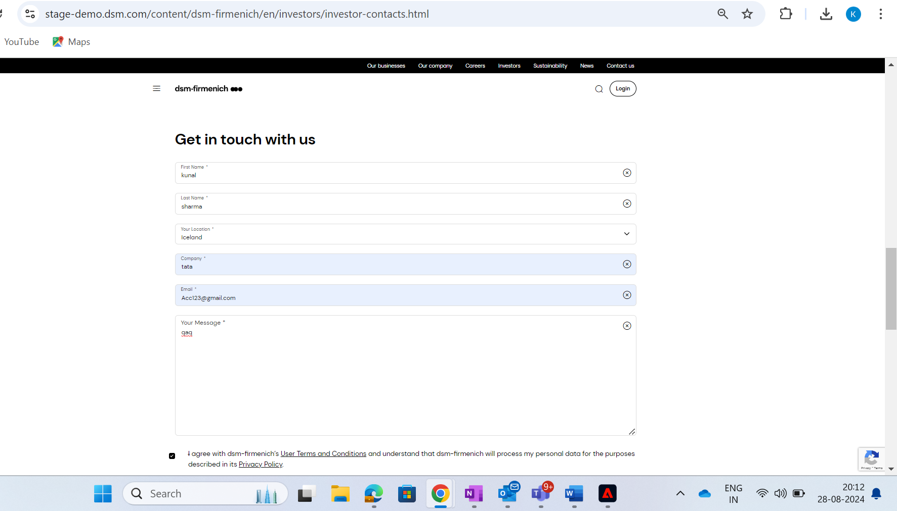

Sustainability:
